MOTHERBOARD

The motherboard serves as a single platform to connect all of the parts of a computer together. It connects the CPU, memory, hard drives, optical drives, video card, sound card, and other ports and expansion cards directly or via cables. It can be considered as the backbone of a computer.

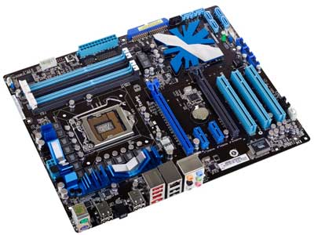

Features of Motherboard

A motherboard comes with following features −

* Motherboard varies greatly in supporting various types of components.
* Motherboard supports a single type of CPU and few types of memories.
* Video cards, hard disks, sound cards have to be compatible with the motherboard to function properly.
* Motherboards, cases, and power supplies must be compatible to work properly together.

Popular Manufacturers

Following are the popular manufacturers of the motherboard.

* Intel
* ASUS
* AOpen
* ABIT
* Biostar
* Gigabyte
* MSI

Description of Motherboard

The motherboard is mounted inside the case and is securely attached via small screws through pre-drilled holes. Motherboard contains ports to connect all of the internal components. It provides a single socket for CPU, whereas for memory, normally one or more slots are available. Motherboards provide ports to attach the floppy drive, hard drive, and optical drives via ribbon cables. Motherboard carries fans and a special port designed for power supply.

There is a peripheral card slot in front of the motherboard using which video cards, sound cards, and other expansion cards can be connected to the motherboard.

On the left side, motherboards carry a number of ports to connect the monitor, printer, mouse, keyboard, speaker, and network cables. Motherboards also provide USB ports, which allow compatible devices to be connected in plug-in/plug-out fashion. For example, pen drive, digital cameras, etc.

# Memory module

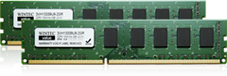

Memory modules are computer chips used to add memory to a computer.

There are two basic distinctions of memory. One is volatile memory where the data is lost as soon as power is removed, and one is non-volatile that can store the data without power. Random access memory (RAM) is used as read-write memory, which the processor can use as a scratch pad and modify rapidly. It utilizes silicon transistors and capacitors to store data but is done so in a grid-like configuration with a transistor-capacitor pair at each intersection of the grid. The advantage of the grid architecture is that it allows any specific bit of information to be read and written at any time. Any point on the grid can be accessed by interrogating the two lines, which will read or write the spot at which they intersect. This type of volatile memory is very fast but the downfall is that the capacitors lose their charge over time so the data must constantly be refreshed. This constant refreshing aspect of the memory is called dynamic RAM or DRAM.

By contrast, static random access memory (SRAM) does not need to be refreshed. Because of this, SRAM is faster because it doesn’t require the time necessary to refresh each bit. SRAM is also more expensive and not used as often. Different types of SRAM may lose the memory after power is removed but some do not.

Non-volatile RAM memory, or NVRAM, is a class of memory that also has a grid architecture, but the data is retained even after the power is removed. Flash memory is an example of a type of NVRAM that utilizes a special type of metal oxide semiconductor field effect transistor (MOSFET) to store data. Other types of NVRAM are ferroelectric RAM (FeRAM) and magnetoresistive ram (MRAM).

Read only memory (ROM) is memory that contains preset instructions and data, often for controlling physical devices like disk drives associated with the PC. ROM is non-volatile so it does not lose what is stored without power. While the name suggests that it is read-only and certain types are, more often it is read-only during normal operation but can be written under the special circumstances. ROM also covers a wide array of memory types.

Programmable read-only memory (PROM) is a type of ROM that is typically programmed once and can’t be changed after that. This type of memory is used in things like firmware and RFID chips. It is often used in hardware that has a dedicated purpose that will not change.EPROM memory is similar to PROM with one key difference. It can be erased and reprogrammed although this is not expected to happen often. The memory chips have an optical window on them, which must be exposed to UV light that will erase the memory and allow them to be reprogrammed. With this method, the memory must be completely erased before any new information is written.

Since the UV light method is somewhat inconvenient, electrically erasable programmable read-only memory (EEPROM) was developed. Erasing and programming are typically done with a voltage higher than normal operation.

**Types**

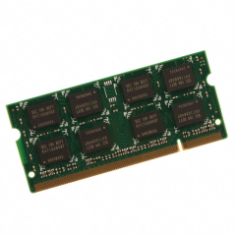

Choices for memory type include:

* RAM (random access memory)
* DRAM (direct random access memory)
* FPM RAM (fast page mode RAM)
* EDO RAM (extended data output RAM)
* BEDO RAM (burst extended data output RAM)
* SDRAM (synchronous DRAM)
* SRAM (static random access memory)
* L2 Cache (level 2 cache)
* Async RAM (asynchronous RAM)
* Sync RAM (synchronous RAM)
* PB SRAM (pipelined burst SRAM)
* VRAM (video RAM)
* WRAM (window RAM)
* SGRAM (synchronous graphics RAM)
* ROM (read only memory)
* PROM (programmable read only memory)
* EPROM (erasable programmable read only memory)
* EEPROM (electronically erasable programmable read only memory)
* Flash

**Specifications**

The form factor of any memory module describes its size and pin configuration. Most computer systems have memory sockets that can accept only one form factor. Choices for form factor include:

* SIMM — Single in-line memory module (SIMM) offers a data path of 32 bits. Because Pentium® memory modules are designed to handle a much wider data path than that, SIMMs must be used in pairs on Pentium motherboards (they can be used singly on boards based on 486 or slower processors).
* DIMM — Dual in line memory module (DIMM), which are of more recent origin, offer a 64-bit path, which makes them more suitable for use with the Pentium and other more recent processors. One DIMM will handle the work of two SIMMs and thus can be used singly on a Pentium motherboard. DIMMs are more economical in the long run, because they can be added one at a time to a system.

**Features**

* Capacity is the amount of data that can be transmitted over a specific period of time.
* Clock speed is the raw MHz that the CPU (Central Processor Unit) operates at. For example, an AMD Athlon 1 GHz has an operating clock speed of 1,000 MHz; this is the processor's clock speed.
* The cycle time is the length of time it takes to transmit data expressed in terms of the minimum amount of time required for a memory to complete a cycle such as read, write, read/write, or read/modify/write.
* Error checking and correction features of memory cards include parity, error checking parity, and nonparity. As data moves through a computer (e.g., from the CPU to the main memory), the possibility of errors can occur, particularly in older machines. Parity error detection was developed to notify the user of any data errors. By adding a single bit to each byte of data, this bit is responsible for checking the integrity of the other 8 bits while the byte is moved or stored. Once a single-bit error is detected, the user receives an error notification; however, parity checking only notifies, and does not correct a failed data bit. If your SIMM module has 3, 6, 9, 12, 18, or 36 chips then it is more than likely parity. Error Checking and Correction (ECC) modules have an extra chip that detects if the data was correctly read or written by the memory module. If the data wasn't properly written, the extra chip will correct it in many cases (depending on what type of error). Non-parity (also called non-ECC) modules do not have an error-detecting feature.

**Applications**

Memory is used in lots of digital electronic devices from smart phones and watches to electronic toothbrushes and radios. Just about any electric device that needs to store information uses some form of memory. For a monitor or TV, this storage may be for the internal software that makes the device run, or as temporary storage for a processor. Many modern appliances such as refrigerators, thermostats, air conditioners, and automobiles use memory, as well as:

* Personal computing
* Motherboards and RAID cards
* Digital electronics
* Servers and networking
* Printers and imaging

# Daughtercard

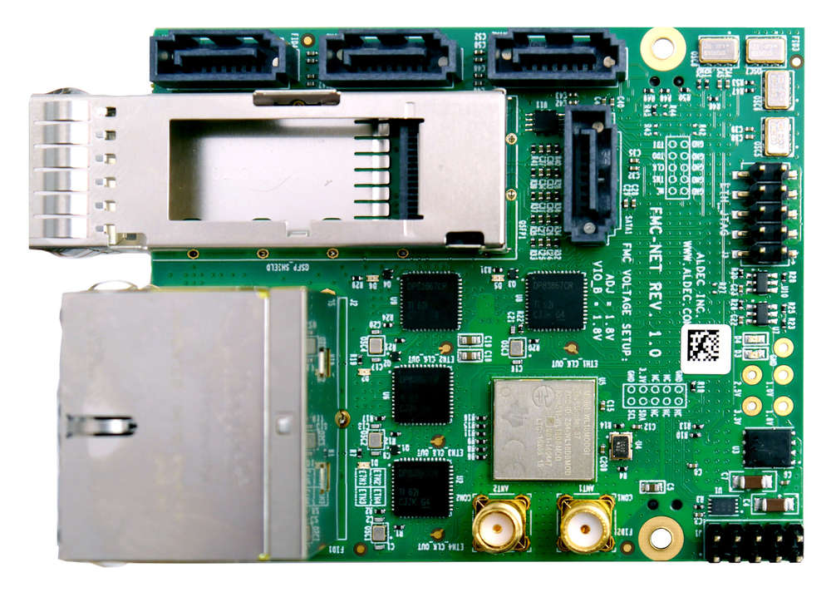

* A daughtercard or [daughterboard](https://www.easytechjunkie.com/what-is-a-daughterboard.htm) is a type of [circuit board](https://www.easytechjunkie.com/what-is-a-circuit-board.htm) that gets added to an existing one. Its name is appropriate for its use, since it is connected to a “[motherboard](https://www.easytechjunkie.com/what-is-a-motherboard.htm)” or “main board.” The motherboard is the primary circuit board for a device. It is usually in the device as it is shipped from the factory. A daughtercard may be added later.
* Daughtercards are common computer components that are joined to the motherboard using edge connectors.
* Some daughtercard designs are made so that engineers can add functionality to a device without requiring a lot more room inside its housing. These kinds of items are often called riser boards or risers. Some might also call them “mezzanine boards.”
* A daughtercard or daughterboard is a type of circuit board that gets added to an existing one.
* Daughtercards are different from some other types of additional circuit boards that tech enthusiasts call “expansion cards.” In expansion cards, the circuit board is often plugged in through a gap in the housing of a computer or device. These expansion boards help to give a device more functionality, often for additional sound play or for better visuals on a high-tech monitor or screen.
* In contrast to the way expansion boards are used, a daughtercard can be a more fundamental enhancement for a device. Adding a daughtercard often requires getting into the guts of a device. That’s why some users might hire a professional to install it. Companies that make an electronic device might offer a daughtercard as part of an essential upgrade that allows the product to be used in more various ways.
* With the rise of connective USB ports and other technology, it has become less necessary to upgrade devices with daughtercards or daughterboards. A lot of advanced use can be built into a wireless connection and “outsourced” to a remote server, rather than adding it physically into a desktop or laptop computer. However, some types of equipment might still get these kinds of additions as provided by the manufacturer. Computer and electronics makers choose the best ways of offering upgrades that they feel will match the needs and desires of their customer base. Since not a lot of laptop or computer users want to wrestle a daughtercard into an existing circuit board design, companies that sell to a consumer market will probably choose alternatives, or offer professional installation as a free service if they are offering a daughtercard as a way to upgrade a device.

# Expansion Slot

An expansion slot refers to any of the slots on a [motherboard](https://www.lifewire.com/motherboards-system-boards-and-mainboards-2618154) that can hold an expansion card to expand the computer's functionality, like a [video card](https://www.lifewire.com/what-is-a-video-card-2618161), network card, or sound card.

The expansion card is plugged directly into the expansion port so that the motherboard has direct access to the [hardware](https://www.lifewire.com/computer-hardware-2625895). However, since all computers have a limited number of expansion slots, it's important to [open your computer](https://www.lifewire.com/how-to-open-a-desktop-computer-case-2624589) and check what's available before you buy one.

Some older systems require the use of a riser board to add additional expansion cards; however, modern computers not only usually have enough expansion slot options, but they also have features integrated directly into the motherboard, eliminating the need for so many expansion cards.

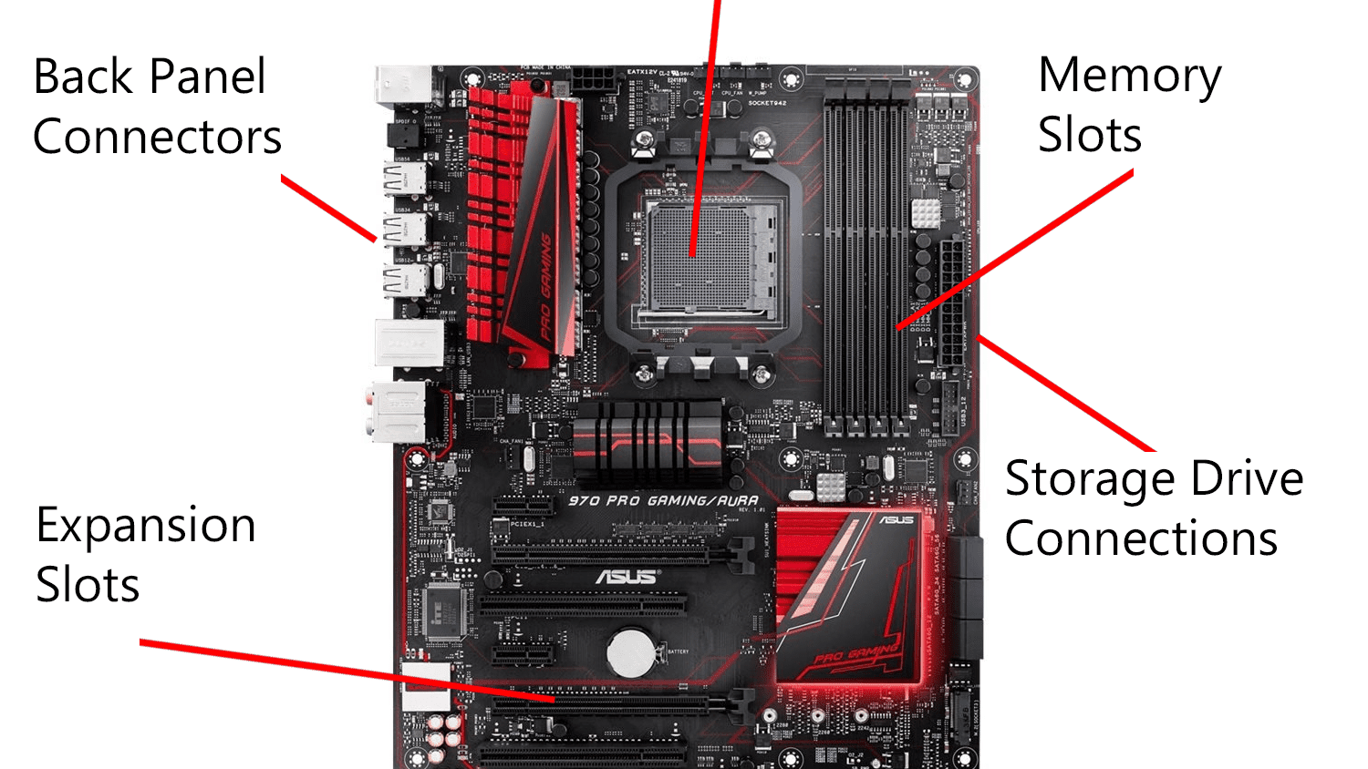

## Different Kinds of Expansion Slots

There have been several types of expansion slots over the years, including PCI, [AGP](https://www.lifewire.com/what-is-accelerated-graphics-port-agp-2625790), AMR, CNR, ISA, EISA, and VESA, but the most popular one used today is [PCIe](https://www.lifewire.com/pci-express-pcie-2625962). While some newer computers still have PCI and AGP slots, PCIe has basically replaced all of the older technologies.

ePCIe, or External PCI Express, is another kind of expansion method but it's an external version of PCIe. That is, it requires a specific kind of cable that extends from the motherboard out the back of the computer, where it connects with the ePCIe device.

## How Do Expansion Slots Work?

Like mentioned above, these expansion ports are used to add various hardware components to the computer, like a new video card, [network card](https://www.lifewire.com/definition-of-adapter-817585), modem, sound card, etc.

Expansion slots have what's called data lanes, which are signaling pairs that are used for sending and receiving data. Each pair has two wires, which makes a lane have a total of four wires. The lane can transfer packets eight [bits](https://www.lifewire.com/definition-of-bit-816250) at a time in either direction.

Since a PCIe expansion port can have 1, 2, 4, 8, 12, 16, or 32 lanes, they're written with an "x," like "x16" to indicate that the slot has 16 lanes. The number of lanes directly relates to the speed of the expansion slot, which is why video cards are usually built to use a x16 port.

## What to Know Before Installing Expansion Cards

An expansion card can be plugged into a slot with a higher number, but not with a lower number. For example, a x1 expansion card will fit with any slot (it will still run at its own speed, though, not the speed of the slot) but a x16 device will not physically fit into a x1, x2, x4, or x8 slot.

When you're installing an expansion card, before removing the computer case, be sure to first power down the computer and unplug the power cord from the back of the [power supply](https://www.lifewire.com/power-supply-unit-2618158). The expansion ports are usually located catty-corner to the [RAM](https://www.lifewire.com/what-is-random-access-memory-ram-2618159) slots, but that might not always be the case.

If the expansion slot hasn't been used before, there will be a metal bracket covering the corresponding slot on the back of the computer. This needs to be removed, usually by unscrewing the bracket, so that the expansion card can be accessed. For example, if you're installing a video card, the opening provides a way to connect the [monitor](https://www.lifewire.com/what-is-a-monitor-2618155) to the card with a video cable (like HDMI, [VGA](https://www.lifewire.com/what-is-vga-2626027), or [DVI](https://www.lifewire.com/understanding-dvi-connections-1846905)).

## Seating the Expansion Card

When seating the expansion card, make sure you're holding on to the metal plate edge and not the gold connectors. When the gold connectors are properly lined up with the expansion slot, press down firmly into the slot, making sure that the edge where the cable connections are is easily accessible from the back of the computer case.

You can remove an existing expansion card by holding on to the metal plate edge, and pulling firmly away from the motherboard, in a straight, upright position. However, some cards have a small clip that keeps it in place, in which case you have to hold back the clip before pulling it out.

Do You Have Room for More Expansion Cards?

Whether or not you have any open expansion slots varies with everyone since not all computers have the exact same hardware installed. However, short of opening your computer and checking manually, there are computer programs that can identify which slots are available and which are used.

For example, [Speccy](https://www.lifewire.com/speccy-review-2625770) is one [free system information tool](https://www.lifewire.com/free-system-information-tools-2625772) that can do just that. Look under the **Motherboard**section and you'll find a list of the expansion slots found on the motherboard. Read the **Slot Usage**line to see if the slot is used or available.

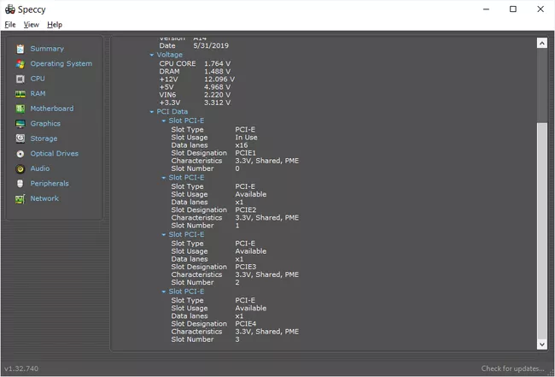

Method 1: Check With the Motherboard Manufacturer

Another method is to check with the motherboard manufacturer. If you know the model of your specific motherboard, you can find out how many expansion cards can be installed by checking with the manufacturer directly or looking through a user manual (which is usually available as a free [PDF](https://www.lifewire.com/pdf-file-2622916) from the manufacturer's website).

If we use the example motherboard from the image at the top of this page, we can access the [motherboard's specifications page on the Asus website](https://www.asus.com/us/SupportOnly/970_PRO_GAMINGAURA/HelpDesk_Knowledge/) to see that it has two PCIe 2.0 x16, two PCIe 2.0 x1, and two PCI expansion slots.

Method 2: Check the Back of Your Computer

One more method you can use to check the available expansion slots on your motherboard is to see which openings are unused on the back of your computer. If there are two brackets still in place, there are most likely two open expansion slots. This method, however, isn't as reliable as checking the motherboard itself since your computer case might not correspond directly with your motherboard.

Do Laptops Have Expansion Slots?

Laptops don't have expansion slots like desktop computers do. A laptop may instead have a little slot on the side that uses either PC Card (PCMCIA) or, for newer systems, ExpressCard.

These ports can be used in a similar fashion to a desktop's expansion slot, like for sound cards, [wireless NICs](https://www.lifewire.com/definition-of-nic-817866), TV tuner cards, [USB](https://www.lifewire.com/universal-serial-bus-usb-2626039) slots, additional storage, etc.

# **Switched-Mode Power Supply (SMPS)**

## What Does Switched-Mode Power Supply (SMPS) Mean?

A switched-mode power supply (SMPS) is an electronic circuit that converts power using switching devices that are turned on and off at high frequencies, and storage components such as inductors or capacitors to supply power when the switching device is in its non-conduction state.

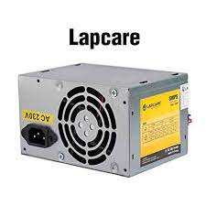Switching power supplies have high efficiency and are widely used in a variety of electronic equipment, including computers and other sensitive equipment requiring stable and efficient power supply.

A switched-mode power supply is also known as a switch-mode power supply or switching-mode power supply.

## Techopedia Explains Switched-Mode Power Supply (SMPS)

Switched-mode power supplies are classified according to the type of input and output voltages. The four major categories are:

* AC to DC
* DC to DC
* DC to AC
* AC to AC

A basic isolated AC to DC switched-mode power supply consists of:

* Input rectifier and filter
* Inverter consisting of switching devices such as MOSFETs
* Transformer
* Output rectifier and filter
* Feedback and control circuit

The input DC supply from a rectifier or battery is fed to the inverter where it is turned on and off at high frequencies of between 20 KHz and 200 KHz by the switching MOSFET or power transistors. The high-frequency voltage pulses from the inverter are fed to the transformer primary winding, and the secondary AC output is rectified and smoothed to produce the required DC voltages. A feedback circuit monitors the output voltage and instructs the control circuit to adjust the duty cycle to maintain the output at the desired level.

There are different circuit configurations known as topologies, each having unique characteristics, advantages and modes of operation, which determines how the input power is transferred to the output.

Most of the commonly used topologies such as flyback, push-pull, half bridge and full bridge, consist of a transformer to provide isolation, voltage scaling, and multiple output voltages. The non-isolated configurations do not have a transformer and the power conversion is provided by the inductive energy transfer.

Advantages of switched-mode power supplies:

* Higher efficiency of 68% to 90%
* Regulated and reliable outputs regardless of variations in input supply voltage
* Small size and lighter
* Flexible technology
* High power density

Disadvantages:

* Generates electromagnetic interference
* Complex circuit design
* Expensive compared to linear supplies

Switched-mode power supplies are used to power a wide variety of equipment such as computers, sensitive electronics, battery-operated devices and other equipment requiring high efficiency.

## Internal Storage Devices

Some storage devices are classed as 'internal' which means they are inside the computer case.

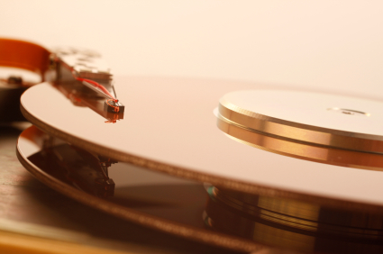Most computers have some form of internal storage. The most common type of internal storage is the hard disk.

At the most basic level, internal storage is needed to hold the operating system so that the computer is able to access the input and output devices.

It will also be used to store the applications software that you use and more than likely, the original copies of your data files.

Internal storage allows the data and applications to be loaded very rapidly into memory, ready for use. The data can be accessed much faster than data which is stored on an external storage device. This is because internal storage devices are connected directly to the motherboard and its data bus whereas external devices are connected through a hardware interface such as USB, which means they are considerably slower to access.

Internal storage also means that if the computer is moved around, it will still retain its most commonly used data.

The main disadvantage of internal storage is that when the hard disk fails (and it will), all the data and applications may be lost.

This can be avoided to some extent by using more than one hard disk within the machine. Each hard disk has a copy of all the data, so if one fails the other can carry on. This is called a RAID array. An alternative is to use external drives for backup.

A Computer Port is an interface or a point of connection between the computer and its peripheral devices. Some of the common peripherals are mouse, keyboard, monitor or display unit, printer, speaker, flash drive etc.

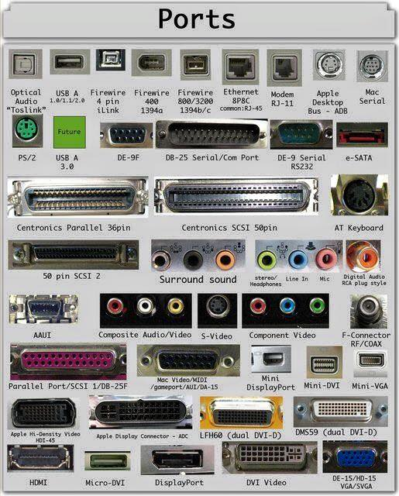The main function of a computer port is to act as a point of attachment, where the cable from the peripheral can be plugged in and allows data to flow from and to the device.

A computer port is also called as a Communication Port as it is responsible for communication between the computer and its peripheral device. Generally, the female end of the connector is referred to as a port and it usually sits on the motherboard.

In Computers, communication ports can be divided into two types based on the type or protocol used for communication. They are Serial Ports and Parallel Ports.

A serial port is an interface through which peripherals can be connected using a serial protocol which involves the transmission of data one bit at a time over a single communication line. The most common type of serial port is a D-Subminiature or a D-sub connector that carry RS-232 signals.

A parallel port, on the other hand, is an interface through which the communication between a computer and its peripheral device is in a parallel manner i.e. data is transferred in or out in parallel using more than one communication line or wire. Printer port is an example of parallel port.

The article gives a brief introduction to different types of ports along with their applications.

### PS/2

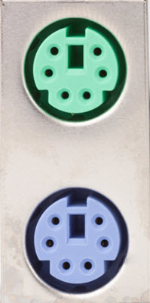PS/2 connector is developed by IBM for connecting mouse and keyboard. It was introduced with IBM’s Personal Systems/2 series of computers and hence the name PS/2 connector. PS/2 connectors are color coded as purple for keyboard and green for mouse.

PS/2 is a 6-pin DIN connector. The pin out diagram of a PS/2 female connector is shown below.

Even though the pinout of both mouse and keyboard PS/2 ports are same, computers do not recognize the devise when connected to wrong port.

PS/2 port is now considered a legacy port as USB port has superseded it and very few of the modern motherboards include it as a legacy port.

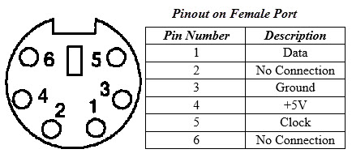

### Serial Port

Even though the communication in PS/2 and USB is serial, technically, the term Serial Port is used to refer the interface that is compliant to RS-232 standard. There are two types of serial ports that are commonly found on a computer: DB-25 and DE-9.

#### DB-25

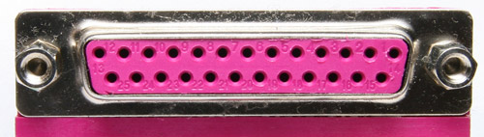DB-25 is a variant of D-sub connector and is the original port for RS-232 serial communication. They were developed as the main port for serial connections using RS-232 protocol but most of the applications did not require all the pins.

Hence, DE-9 was developed for RS-232 based serial communication while DB-25 was rarely used as a serial port and often used as a parallel printer port as a replacement of the Centronics Parallel 36 pin connector.

#### DE-9 or RS-232 or COM Port

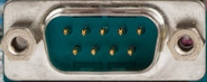DE-9 is the main port for RS-232 serial communication. It is a D-sub connector with E shell and is often miscalled as DB-9. A DE-9 port is also called as a COM port and allows full duplex serial communication between the computer and it’s peripheral.

Some of the applications of DE-9 port are serial interface with mouse, keyboard, modem, uninterruptible power supplies (UPS) and other external RS-232 compatible devices.

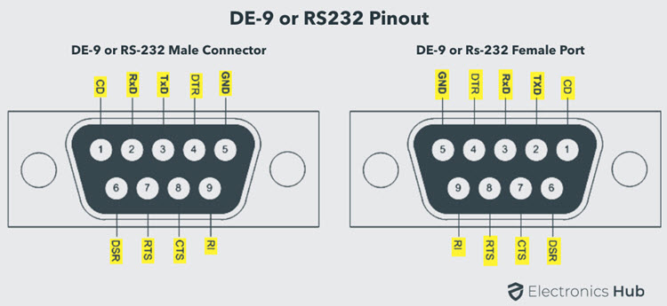The pinout diagram of DE-9 port is shown below.

The use of DB-25 and DE-9 ports for communication is in decline and are replaced by USBs or other ports.

### Parallel Port or Centronics 36 Pin Port

Parallel port is an interface between computer and peripheral devices like printers with parallel communication. The Centronics port is a 36 pin port that was developed as an interface for printers and scanners and hence a parallel port is also called as a Centronics port.

Before the wide use of USB ports, parallel ports are very common in printers. The Centronics port was later replaced by DB-25 port with parallel interface.

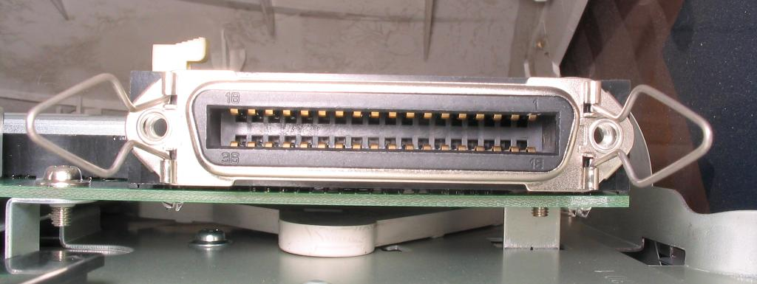

### Audio Ports

Audio ports are used to connect speakers or other audio output devices with the computer. The audio signals can be either analogue or digital and depending on that the port and its corresponding connector differ.

#### Surround Sound Connectors or 3.5 mm TRS Connector

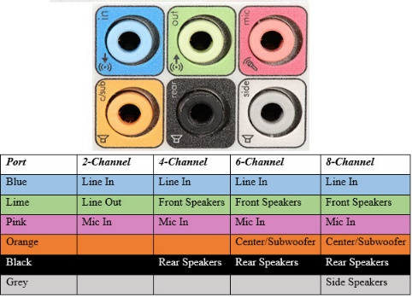It is the most commonly found audio port that can be used to connect stereo headphones or surround sound channels. A 6 connector system is included on majority of computers for audio out as well as a microphone connection.

The 6 connectors are color coded as Blue, Lime, Pink, Orange, Black and Grey. These 6 connectors can be used for a surround sound configuration of up to 8 channels.

### S/PDIF / TOSLINK

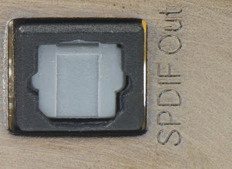The Sony/Phillips Digital Interface Format (S/PDIF) is an audio interconnect used in home media. It supports digital audio and can be transmitted using a coaxial RCA Audio cable or an optical fiber TOSLINK connector.

Most computers home entertainment systems are equipped with S/PDIF over TOSLINK. TOSLINK (Toshiba Link) is most frequently used digital audio port that can support 7.1 channel surround sound with just one cable. In the following image, the port on the right is an S/PDIF port.

### Video Ports

#### VGA Port

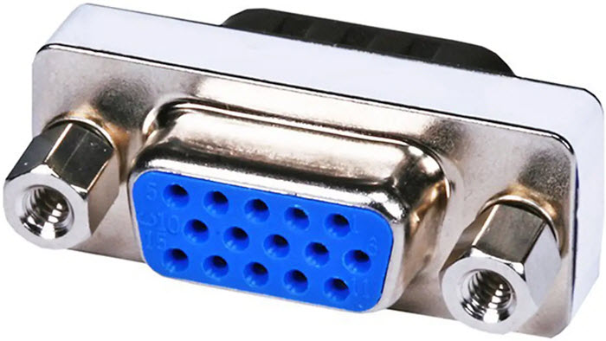VGA port is found in many computers, projectors, video cards and High Definition TVs. It is a D-sub connector consisting of 15 pins in 3 rows. The connector is called as DE-15.

VGA port is the main interface between computers and older CRT monitors. Even the modern LCD and LED monitors support VGA ports but the picture quality is reduced. VGA carries analogue video signals up to a resolution of 648X480.

With the increase in use of digital video, VGA ports are gradually being replaced by HDMI and Display Ports. Some laptops are equipped with on-board VGA ports in order to connect to external monitors or projectors. The pinout of a VGA port is shown below.

### Digital Video Interface (DVI)

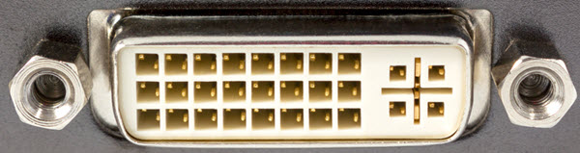DVI is a high speed digital interface between a display controller like a computer and a display device like a monitor. It was developed with an aim of transmitting lossless digital video signals and replace the analogue VGA technology.

There are three types of DVI connectors based on the signals it can carry: DVI-I, DVI-D and DVI-A. DVI-I is a DVI port with integrated analogue and digital signals. DVI-D supports only digital signals and DVI-A supports only analogue signals.

The digital signals can be either single link or dual link where a single link supports a digital signal up to 1920X1080 resolution and a dual link supports a digital signal up to 2560X1600 resolution. The following image compares the structures of DVI-I, DVI-D and DVI-A types along with the pinouts.

#### Mini-DVI

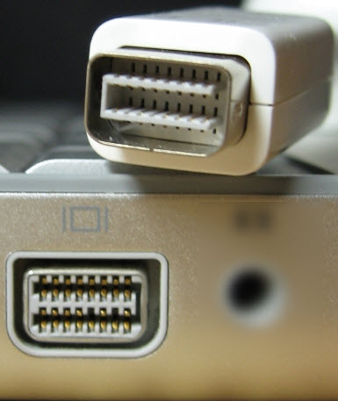Mini-DVI port is developed by Apple as an alternative to Mini-VGA port and is physically similar to one. It is smaller than a regular DVI port.

It is a 32 pin port and is capable of transmitting DVI, composite, S-Video and VGA signals with respective adapters. The following image shows a Mini-DVI port and its compatible cable.

#### Micro-DVI

Micro-DVI port, as the name suggests is physically smaller than Mini-DVI and is capable of transmitting only digital signals.

This port can be connected to external devices with DVI and VGA interfaces and respective adapters are required. In the following image, a Micro-DVI port can be seen adjacent to headphone and USB ports.

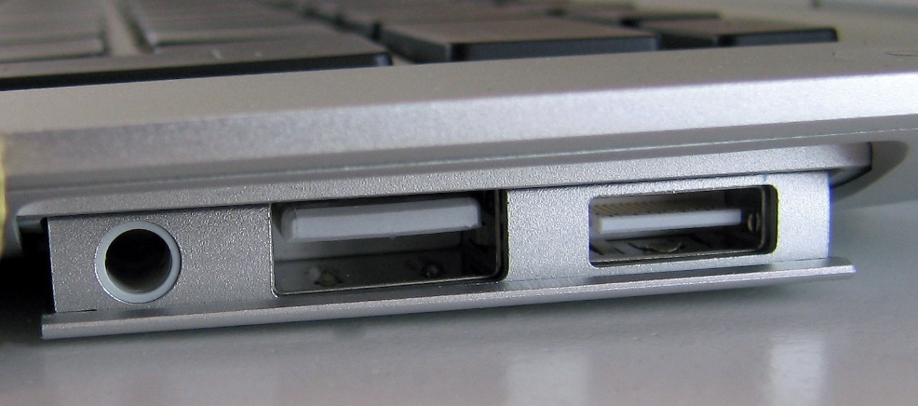

### Display Port

Display Port is a digital display interface with optional multiple channel audio and other forms of data. Display Port is developed with an aim of replacing VGA and DVI ports as the main interface between a computer and monitor.

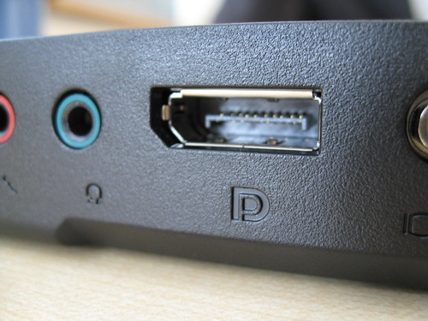The latest version DisplayPort 1.3 can handle a resolution up to 7680 X 4320.

The Display Port has a 20 pin connector, which is a very less number when compared to DVI port and offers better resolution. The pin out diagram of a Display Port is shown below.

**Update:** DisplayPort 1.4a is the latest (in production) version of DisplayPort Specification with support for 4K (3840 x 2160) at 120 Hz or 8K (7680 x 4320) at 60 Hz. An improved DisplayPort version 2.0 specification is released in June of 2019 with an increased bandwidth of 77.37 Gbps (approximately).

#### Mini DisplayPort

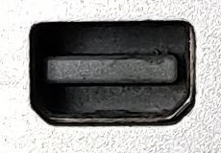Apple introduced a miniature version of DisplayPort and called it Mini DisplayPort (mDP or Mini DP). Even though Mini DisplayPort has 20 pins, the physical size of the connector is smaller than a regular DisplayPort and the pin out is also different.

Most laptops provide Mini DisplayPort as an additional video out option in addition to HDMI.

### RCA Connector

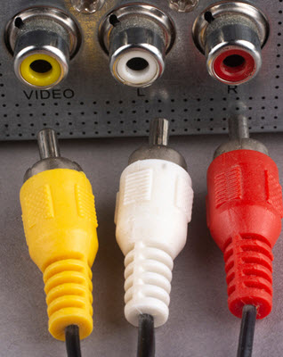RCA Connector can carry composite video and stereo audio signals over three cables. Composite video transmits analogue video signals and the connector is as yellow colored RCA connector.

The video signals are transmitted over a single channel along with the line and frame synchronization pulses at a maximum resolution of 576i (standard resolution).

The red and white connectors are used for stereo audio signals (red for right channel and white for left channel).

### Component Video

Component Video is an interface where the video signals are split into more than two channels and the quality of the video signal is better that Composite video.

Like composite video, component video transmits only video signals and two separate connectors must be used for stereo audio. Component video port can transmit both analogue and digital video signals.

The ports of the commonly found Component video uses 3 connectors and are color coded as Green, Blue and Red.

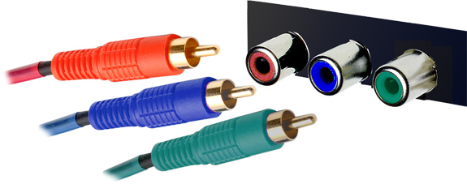

### S-Video

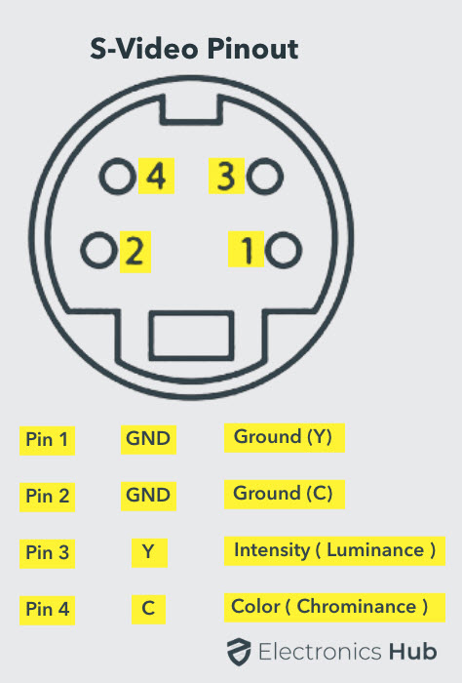S-Video or Separate Video connector is used for transmitting only video signals. The picture quality is better than that of Composite video but has a lesser resolution than Component video.The S-Video port is generally black in color and is present on all TVs and most computers. S-Video port looks like a PS/2 port but consists of only 4 pins.

Out of the 4 pins, one pin is used to carry the intensity signals (black and white) and other pin is used to carry color signals. Both these pins have their respective ground pins. The pinout diagram of an S-Video port is shown below.

HDMI

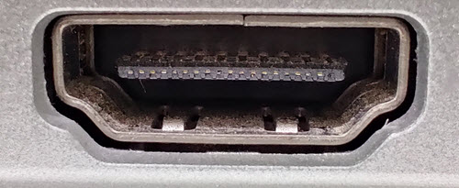HDMI is an abbreviation of High Definition Media Interface. HDMI is a digital interface to connect High Definition and Ultra High Definition devices like Computer monitors, HDTVs, Blu-Ray players, gaming consoles, High Definition Cameras etc.

HDMI can be used to carry uncompressed video and compressed or uncompressed audio signals. The HDMI port of type A is shown below.

The HDMI connector consists of 19 pins and the latest version of HDMI i.e. HDMI 2.0 can carry digital video signal up to a resolution of 4096×2160 and 32 audio channels. The pinout diagram of an HDMI port is as follows.

**Update:** The latest version of HDMI is 2.1 with much improved bandwidth, resolution and support from video card manufacturers. While HDMI 2.0 has a data bandwidth of 18 Gbps, the HDMI 2.1 has a staggering 48 Gbps of bandwidth. Coming to the display resolution, HDMI 2.1 supports 4K and 8K at 120 Hz refresh rate. Most modern (at least high end) graphics cards like Nvidia RTX 3090 provide at least a couple of HDMI 2.1 Ports to connect with monitors and TVs.

#### Mini HDMI

With HDMI 1.3 Version, a new HDMI Port and Connector combination is released called the Mini HDMI. Physically, it is smaller than a regular HDMI Port but has same 19 Pin. Intended for portable devices like laptops, cameras, camcorders, the Mini HDMI Port isn’t that popular.

#### Micro HDMI

HDMI developers introduced a new HDMI Connector and Port called Micro HDMI with HDMI Version 1.4. Micro HDMI also has 19 pins (just like regular HDMI and Mini HDMI) but the pinout is different.

Micro HDMI is often used in cameras, single board computers (like Raspberry Pi 4), etc. where physically it is difficult to include a regular HDMI port.

The size of Micro HDMI is significantly smaller than regular HDMI and has some resemblance to a micro–USB Port (sometimes people confuse among the two). The port on the left is a micro USB port and the one on the right is a micro HDMI Port.

### USB

Universal Serial Bus (USB) replaced serial ports, parallel ports, PS/2 connectors, game ports and power chargers for portable devices.

USB port can be used to transfer data, act as an interface for peripherals and even act as power supply for devices connected to it. There are three kinds of USB ports: Type A, Type B or mini USB and Micro USB.

#### USB Type A

USB Type-A port is a 4 pin connector. There are different versions of Type – A USB ports: USB 1.1, USB 2.0 and USB 3.0. USB 3.0 is the common standard and supports a data rate of 400MBps.

USB 3.1 is also released and supports a data rate up to 10Gbps. Usually, but not all the times, the USB 2.0 is Black color coded and USB 3.0 is Blue. The following image shows USB 2.0 and USB 3.0 ports.

The pinout diagram of USB Type – A port is shown below. The pinout is common to all standards of Type – A.

#### USB Type C

USB Type – C is the latest specification of the USB and is a reversible connector. USB Type – C is supposed to replace Types A and B and is considered future proof.

The port of USB Type – C consists of 24 pins. The pinout diagram of USB Type – C is shown below. The latest USB Specifications (USB4) is an USB-C only specification i.e., only USB type C devices can be used with USB4 specifications.

In the latest USB4 specification, USB Type C Devices can support speeds up to 40 Gbps.

USB Power Delivery specifications allow USB devices to supply power to devices connected to the USB Port. USB Type – C can handle a current of 5A at 20V (only Power Delivery certified USB Type-C Ports).

This feature of handling high current is used in the latest Fast Charging Technology where a Smart Phone’s battery will reach its full charge is very less time. So, USB Type C Ports can provide up to 100W of power (which can be used for charging mobile phones and laptops).

In fact, the latest Apple M1 Mac Books use 61W USB C Power Adapter.

### RJ-45

Ethernet is a networking technology that is used to connect your computer to Internet and communicate with other computers or networking devices.

The interface that is used for computer networking and telecommunications is known as Registered Jack (RJ) and RJ – 45 port in particular is used for Ethernet over cable. RJ-45 connector is an 8 pin – 8 contact (8P – 8C) type modular connector.

The latest Ethernet technology is called Gigabit Ethernet and supports a data transfer rate of over 10Gigabits per second. The Ethernet or a LAN port with 8P – 8C type connector along with the male RJ-45 cable is shown below.

The un-keyed 8P – 8C modular connector is generally referred to the Ethernet RJ-45. Often, RJ-45 ports are equipped with two LEDs for indicating transmission and packet detection.

As mentioned earlier, an Ethernet RJ-45 port has 8 pins and the following picture depicts the pinout of one.

### RJ-11

RJ-11 is another type of Registered Jack that is used as an interface for telephone, modem or ADSL connections. Even though computers are almost never equipped with an RJ-11 port, they are the main interface in all telecommunication networks.

RJ-45 and RJ11 ports look alike but RJ-11 is a smaller port and uses a 6 point – 4 contact (6P – 4C) connector even though a 6 point – 2 contact (6P – 2C) is sufficient. The following is a picture of an RJ-11 port and its compatible connector.

The following image can be used to compare RJ-45 and RJ-11 ports.

### e-SATA

e-SATA is an external Serial AT Attachment connector that is used as an interface for connecting external mass storage devices. Modern e-SATA connector are called e-SATAp and stands for Power e-SATA ports.

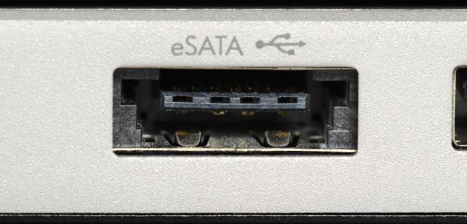They are hybrid ports capable of supporting both e-SATA and USB. Neither the SATA organization nor the USB organization has officially approved the e-SATAp port and must be used at user’s risk.

The above image is of an e-SATAp port. It shows that both e-SATA and USB devices can be connected.